Your Extended Abstract´s Title Starts Here:
Please Center and use Calibri (size 12)
First name surname Presenting First Author¹, Second Author² and Others³
¹Full address of presenting/first author, including country, email
²Full address of second author, including country, email
³List all distinct addresses in the same way

For the rest of the paper, please use Calibri (size 10)
(please do not change the document setting from A4 to letter)
The extended abstract should not exceed 2 pages. All manuscripts must be in English.
Please use the following abstract structure:
Introduction
In the introduction the main objectives of the work should be provided in the framework of an adequate background. Please avoid a detailed literature survey.

Materials and Methods
Details on materials, production, treatment and analyzing methods should be provided to allow the work to be reproduced. Methods already published should be indicated by a reference: only relevant modifications should be described.

Results and Discussion
Results should be clear and concise. This should explore the significance of the results of the work. Please avoid extensive citations and discussion of published literature.
You may use equations, figures or a table as described below.

Equations
Equations should be referred with Eq. 1, Eq. 2. There should be one line of space above the equation and one line of space below it before the text continues. The equations have to be numbered sequentially, and the number put in parentheses at the right-hand edge of the text. Equations should be punctuated as if they were an ordinary part of the text. Punctuation appears after the equation but before the equation number, e.g.
c² = a² + b². (1)

Figures (or Table)
The text may include 1 or 2 figures (refer with Fig. 1 and Fig. 2), which should be formatted as seen in the example above. Each figure should have a brief caption describing it and, a key to interpret various symbols, lines or colored regions. Color figures are welcome (for the online version). Please note, that abstracts and figures will be printed in black/white.

Optionally, one table may be included in the text instead of the figure(s).

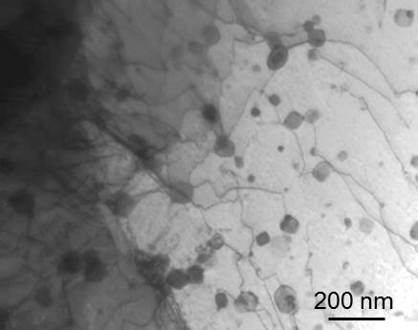 | 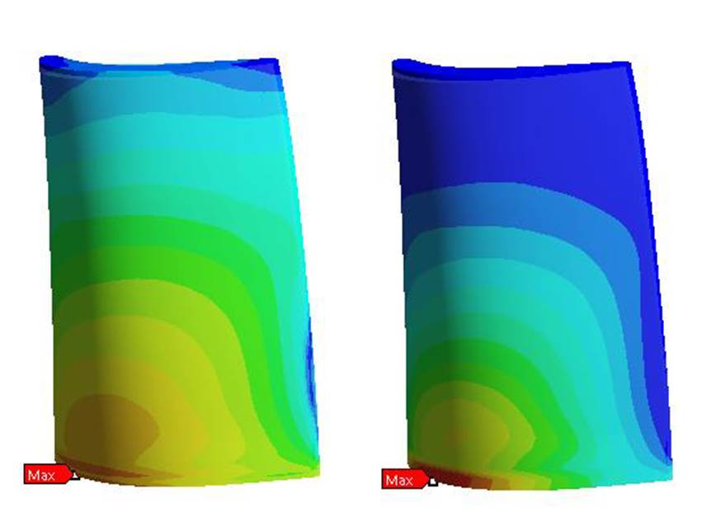
Fig. 1: Text | Fig. 2: Text

Literature References
References are cited in the text just by square brackets [1]. Two or more references at a time may be put in one set of brackets [3,4]. The references are to be numbered in the order in which they are cited in the text and are to be listed at the end of the contribution under the heading References.

References
[1] L. Weng, X. Zhang, J. Han, W. Han, C. Hong, Journal of Alloys and Compounds. 2009, 473, 314-318.
[2] P. Rogl, in: W. Martienssen, G. Effenberg, S. Ilyenko (Eds.): Refractory Metal Systems. Springer Berlin Heidelberg, Berlin, Heidelberg, 2009, 384–421.
[3] P.A. Green: submitted to Journal of Materials Research. 2003.

